**Elderberry inventory management**

1. **Contact Information**

Sponsor: Theresa Echols Phone #: 1-801-367-2153 E-mail: elderberryfamilyfarms@gmail.com

Team Member: Tyler Echols Phone #: 1-801-380-7912 E-mail: tyechols@live.com

Team Member:Sara Chalabi Phone #: 90-552-259-7614 E-mail: chalabi85@gmail.com

Team Member: Claudio Lbartuni Lolkipayangi Phone #: E-mail

1. **An overview of the problem**

This is an inventory management aid. It will let users track and update how many of each ingredient and product are currently in inventory. It will be designed for use on Android phones, assuming Android is in the scope of this class.

1. **Core features and Stretch goals**

**Required features:**

Persistent data recording number of items. Ability to change and save that data

**Stretch goal:**

Desired product stockpile: Let user set a minimum amount of product, and display whether current amount has dipped below that minimum. Shopping list: Compile a list of all products that have dipped below desired minimum amounts. Recipe: New data type, which tracks how much of each ingredient goes into a given product. Batch Calculator: User chooses a recipe and how many times to make it. Program calculates how many total ingredients are needed and references that against how many are in storage. Program shows total ingredient amounts and a shopping list, if appropriate.

1. **An overview of the design / approach**

(describe your overall approach to the problem including a description of the major, high-level components you will have, and how they will interact.)

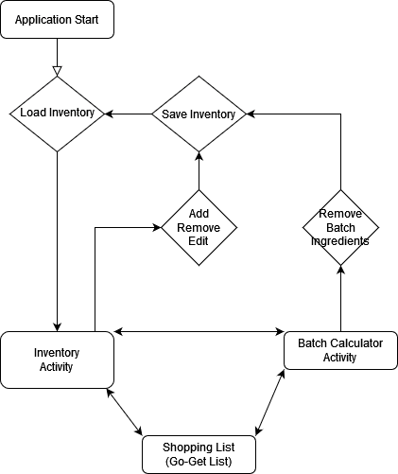

1. **UML** (showing the classes you will have and the relations among them)

1. **Diagram

   Description automatically generatedUser interface plans** (likely showing some rough mock-ups)

